Postman details to check the output:

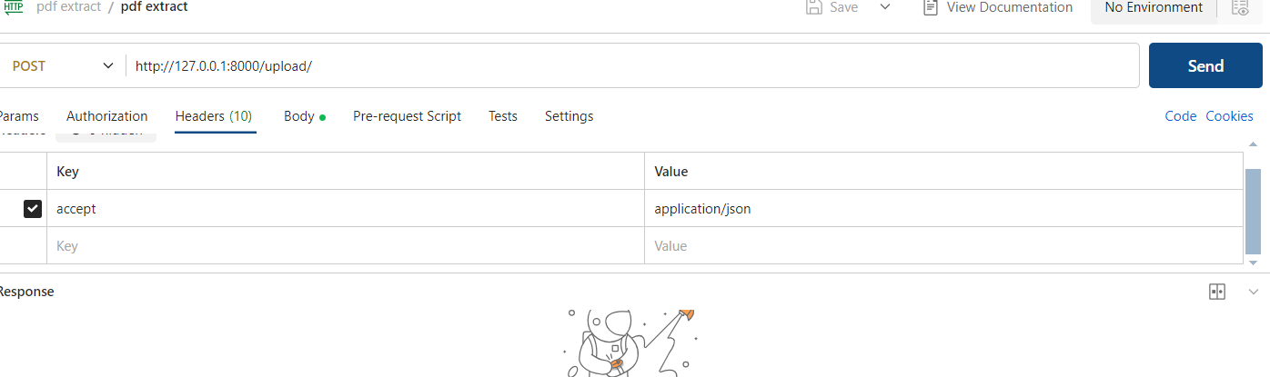  
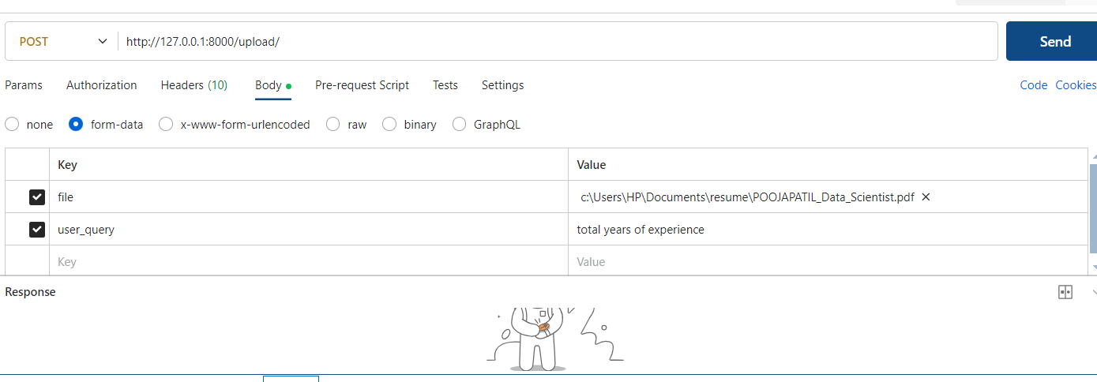

If we want to run the application without docker   
step1: install the ollama in local machine   
step2: pull the deepseek-r1:1.5b model

Step3 : uncomment the code first code and comment 2nd code   
step4: run this command in VScode terminal : uvicorn main:app –reload

Output of the model:  
